**Basic Shell Commands**

**Ans to question 4 :**

**We use rm to delete a directory or a file when it is non-empty.**

**We use rmdir to delete a directory or a file when it is empty.**

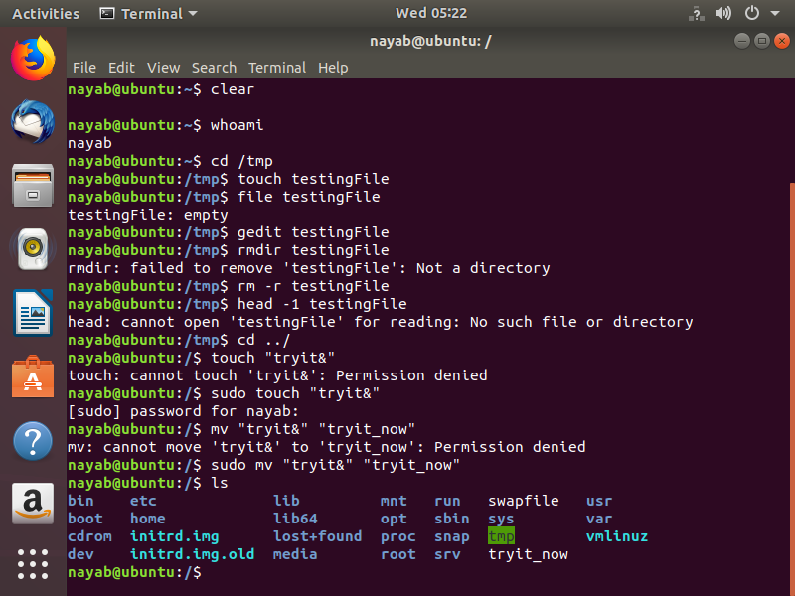

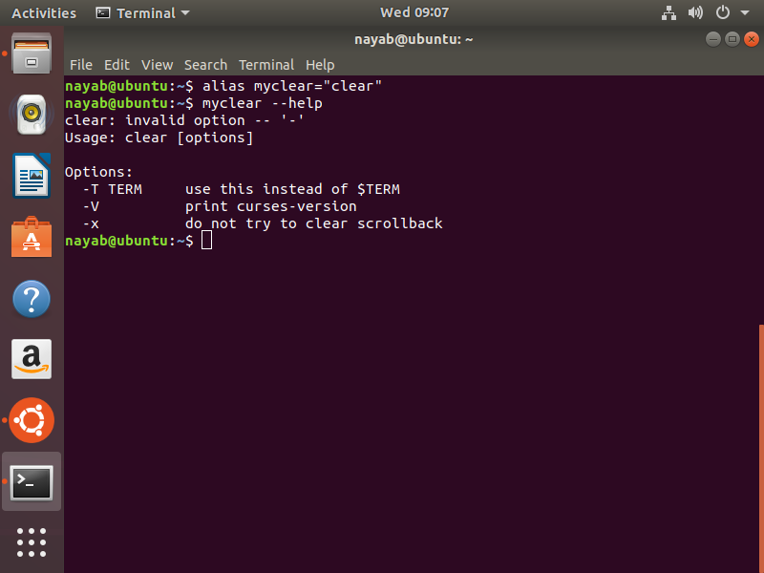

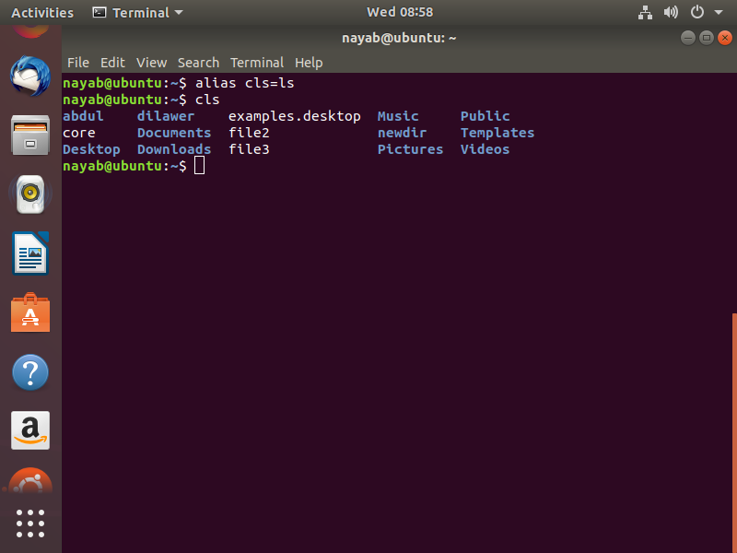

**Ans to question 8:**

**Output = ls**

**i.e. cls will work same as ls does.**

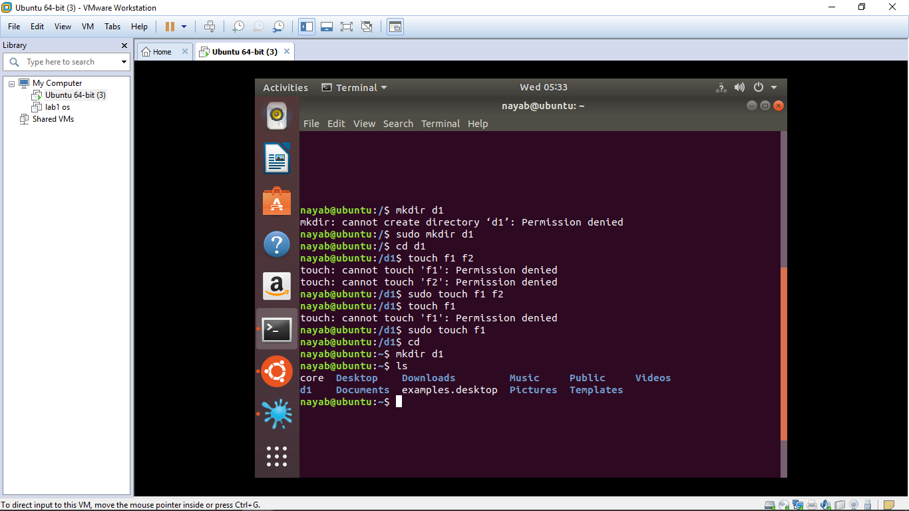

**Ans to Question 9:**

**Directory having name d1 is created.**

**QUESTIONS:**

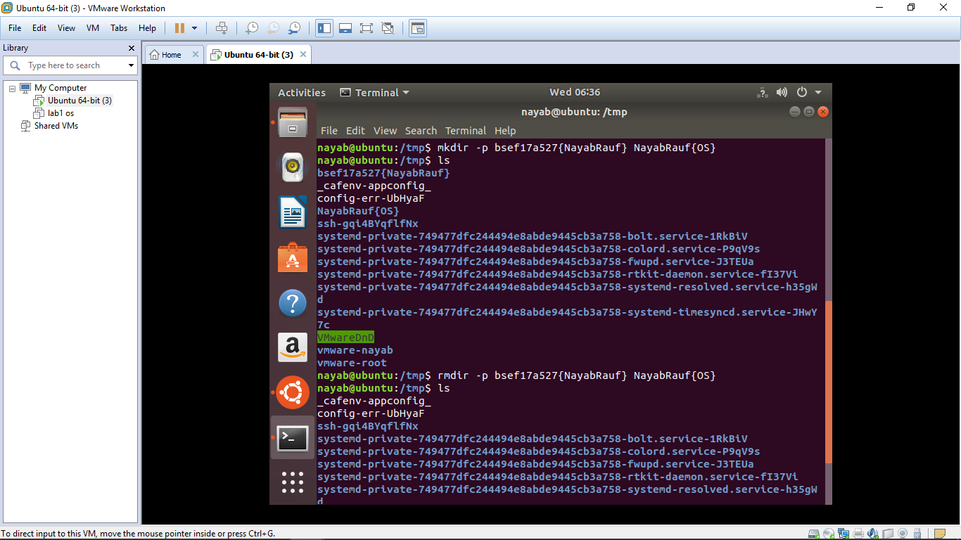

**2) Hidden files can be displayed on screen with the command “ls -a” .**

**3) All the 3 directories can be removed by the command rmdir(if empty)**

**And rm -r (when non-empty).**

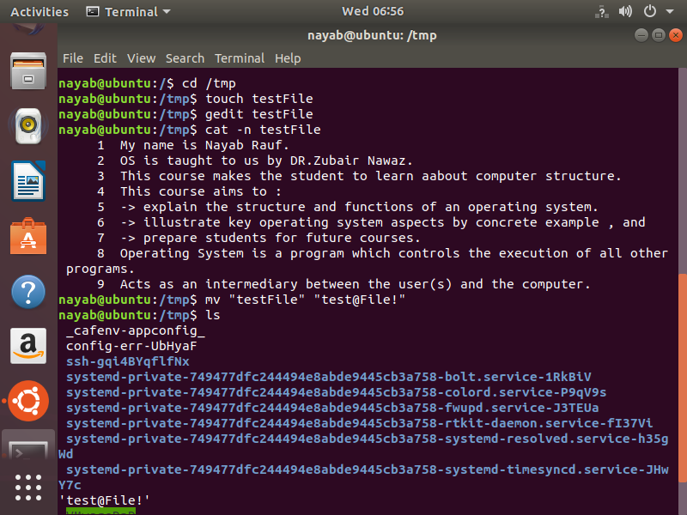

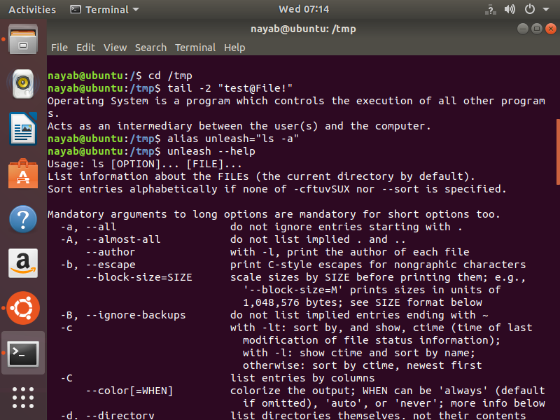

**8) To see the details of a command we use man or --help.**

**10) rm -r also use to remove directory .**

**Absolute/Relative Path :**

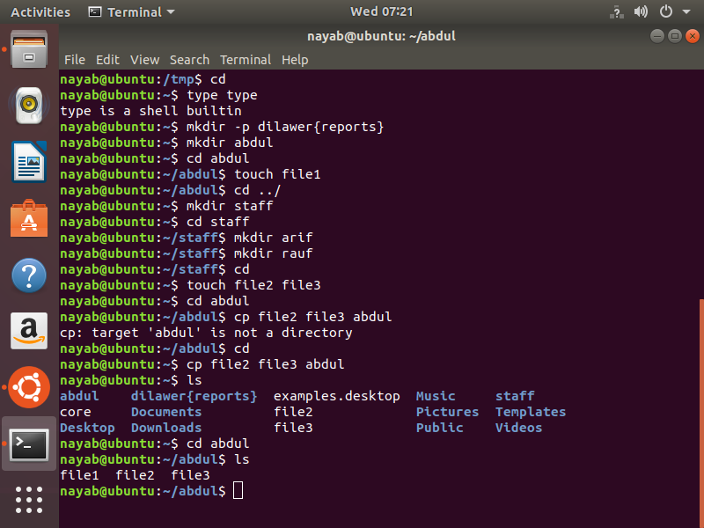

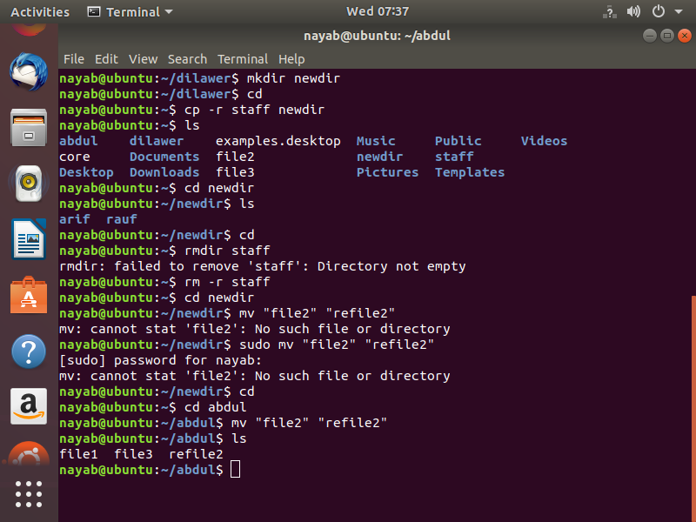

**a**